**Introduction**

Completed100 XP

* 6 minutes

**Microsoft Power BI** is a collection of software services, apps, and connectors that work together to turn your unrelated sources of data into coherent, visually immersive, and interactive insights. Whether your data is a simple Microsoft Excel workbook, or a collection of cloud-based and on-premises hybrid data warehouses, **Power BI** lets you easily connect to your data sources, visualize (or discover) what's important, and share that with anyone or everyone you want.

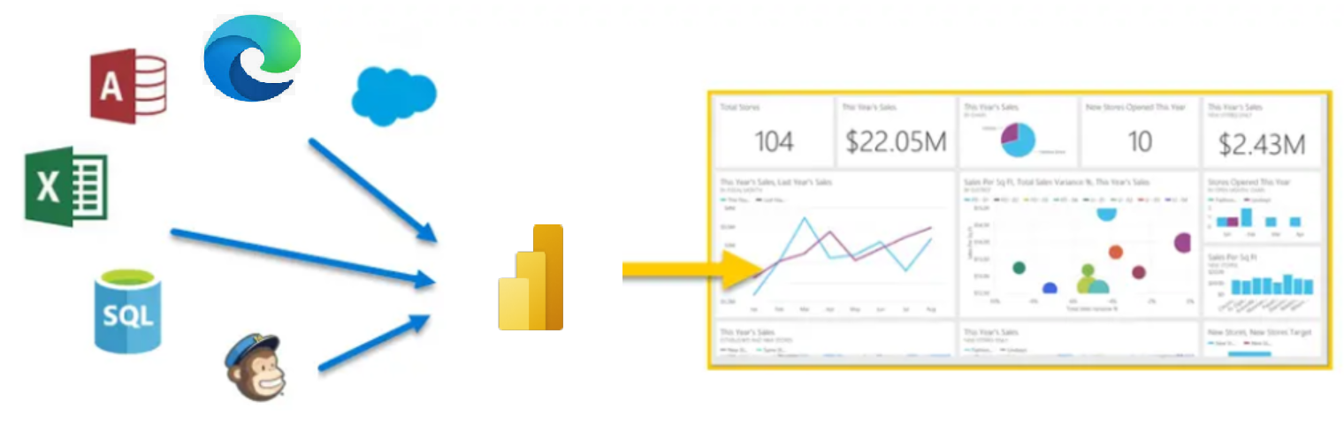

**Power BI** can be simple and fast, capable of creating quick insights from an Excel workbook or a local database. But **Power BI** is also robust and enterprise-grade, ready not only for extensive modeling and real-time analytics, but also for custom development. Therefore, it can be your personal report and visualization tool, but can also serve as the analytics and decision engine behind group projects, divisions, or entire corporations.

If you're a **beginner** with Power BI, this module will get you going. If you're a Power BI **veteran**, this module will tie concepts together and fill in the gaps.

**The parts of Power BI**

Power BI consists of a Microsoft Windows desktop application called **Power BI Desktop**, an online SaaS (*Software as a Service*) service called the **Power BI service**, and mobile Power BI **apps** that are available on any device, with native mobile BI apps for Windows, iOS, and Android.

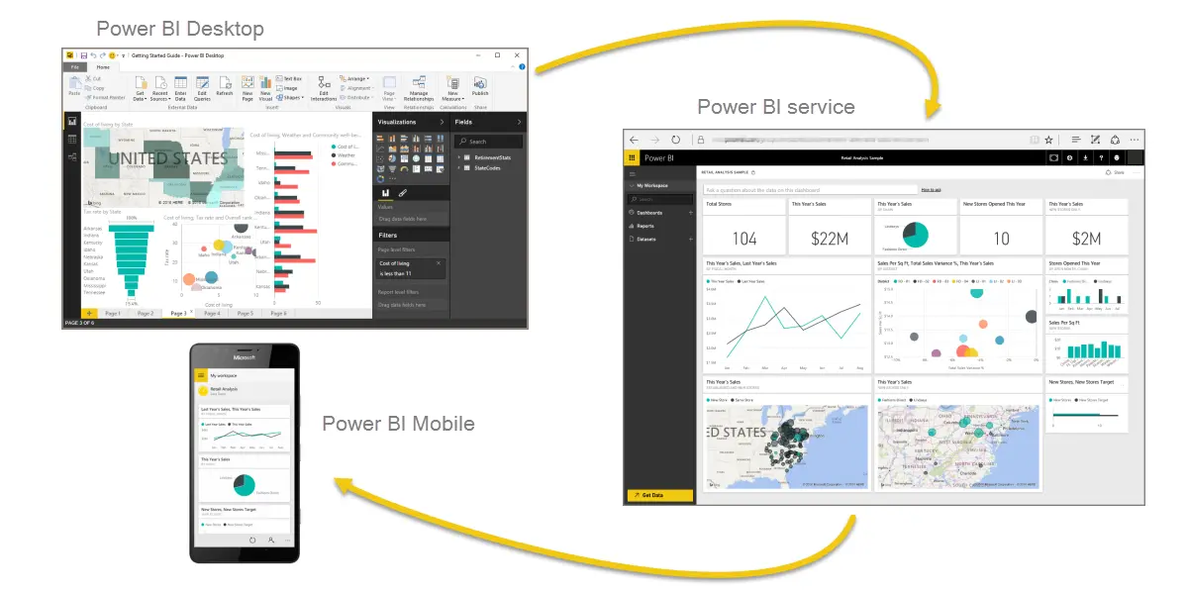

These three elements—**Desktop**, the **service**, and **Mobile** apps—are designed to let people create, share, and consume business insights in the way that serves them, or their role, most effectively.

**How Power BI matches your role**

How you use Power BI might depend on your role on a project or a team. And other people, in other roles, might use Power BI differently, which is just fine.

For example, you might view reports and dashboards in the **Power BI service**, and that might be all you do with Power BI. But your number-crunching, business-report-creating coworker might make extensive use of **Power BI Desktop** (and publish Power BI Desktop reports to the Power BI service, which you then use to view them). And another coworker, in sales, might mainly use her Power BI phone app to monitor progress on her sales quotas and drill into new sales lead details.

You also might use each element of **Power BI** at different times, depending on what you're trying to achieve, or what your role is for a given project or effort.

Perhaps you view inventory and manufacturing progress in a real-time dashboard in the service, and also use **Power BI Desktop** to create reports for your own team about customer engagement statistics. How you use Power BI can depend on which feature or service of Power BI is the best tool for your situation. But each part of Power BI is available to you, which is why it's so flexible and compelling.

We discuss these three elements—**Desktop**, the **service**, and **Mobile** apps—in more detail later. In upcoming units and modules, we'll also create reports in Power BI Desktop, share them in the service, and eventually drill into them on our mobile device.

**Download Power BI Desktop**

You can download Power BI Desktop from the web or as an app from the Microsoft Store on the Windows tab.

| **Download Strategy** | **Link** | **Notes** |
| --- | --- | --- |
| Windows Store App | [Windows Store](https://aka.ms/pbidesktopstore) | Will automatically stay updated |
| Download from web | [Download .msi](https://go.microsoft.com/fwlink/?LinkID=521662) | Must manually update periodically |

**Sign in to Power BI service**

Before you can sign in to Power BI, you'll need an account. To get a free trial, go to [app.powerbi.com](https://go.microsoft.com/fwlink/?linkid=2101313) and sign up with your email address.

For detailed steps on setting up an account, see [Sign in to Power BI service](https://learn.microsoft.com/en-us/power-bi/consumer/end-user-sign-in)

**The flow of work in Power BI**

A common flow of work in Power BI begins in **Power BI Desktop**, where a report is created. That report is then published to the **Power BI service** and finally shared, so that users of **Power BI Mobile** apps can consume the information.

It doesn't always happen that way, and that's okay. But we'll use that flow to help you learn the different parts of Power BI and how they complement each other.

Okay, now that we have an overview of this module, what Power BI is, and its three main elements, let's take a look at what it's like to use **Power BI**.

**Next unit: Use Power BI**

**Use Power BI**

Completed100 XP

* 2 minutes

Now that we've introduced the basics of Microsoft Power BI, let's jump into some hands-on experiences and a guided tour.

The activities and analyses that you'll learn with Power BI generally follow a common flow. The **common flow** of activity looks like this:

1. Bring data into Power BI Desktop, and create a report.
2. Publish to the Power BI service, where you can create new visualizations or build dashboards.
3. Share dashboards with others, especially people who are on the go.
4. View and interact with shared dashboards and reports in Power BI Mobile apps.

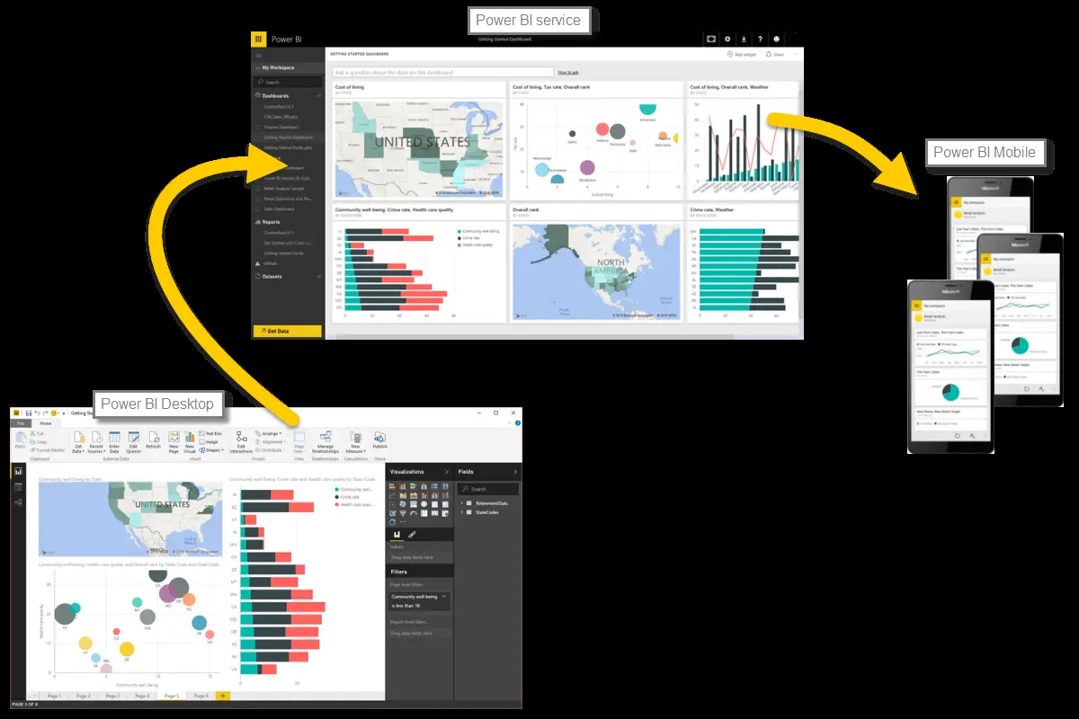

As mentioned earlier, you might spend all your time in the **Power BI service**, viewing visuals and reports that have been created by others. And that's fine. Someone else on your team might spend their time in **Power BI Desktop**, which is fine too. To help you understand the full continuum of Power BI and what it can do, we'll show you all of it. Then you can decide how to use it to your best advantage.

So, let's jump in and step through the experience. Your first order of business is to learn the basic building blocks of Power BI, which will provide a solid basis for turning data into cool reports and visuals.

**Next unit: Building blocks of Power BI**

**Building blocks of Power BI**

Completed100 XP

* 12 minutes

Everything you do in Microsoft Power BI can be broken down into a few basic **building blocks**. After you understand these building blocks, you can expand on each of them and begin creating elaborate and complex reports. After all, even seemingly complex things are built from basic building blocks. For example, buildings are created with wood, steel, concrete and glass, and cars are made from metal, fabric, and rubber. Of course, buildings and cars can also be basic or elaborate, depending on how those basic building blocks are arranged.

Let's take a look at these basic building blocks, discuss some simple things that can be built with them, and then get a glimpse into how complex things can also be created.

Here are the basic building blocks in Power BI:

* Visualizations
* Datasets
* Reports
* Dashboards
* Tiles

**Visualizations**

A **visualization** (sometimes also referred to as a **visual**) is a visual representation of data, like a chart, a color-coded map, or other interesting things you can create to represent your data visually. Power BI has all sorts of visualization types, and more are coming all the time. The following image shows a collection of different visualizations that were created in Power BI.

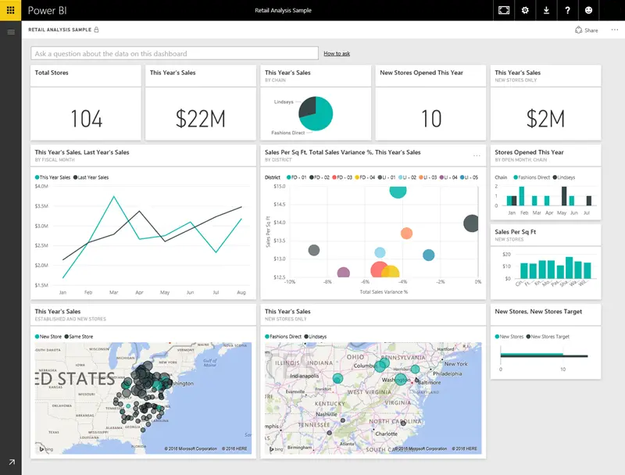

Visualizations can be simple, like a single number that represents something significant, or they can be visually complex, like a gradient-colored map that shows voter sentiment about a certain social issue or concern. The goal of a visual is to present data in a way that provides context and insights, both of which would probably be difficult to discern from a raw table of numbers or text.

**Datasets**

A **dataset** is a collection of data that Power BI uses to create its visualizations.

You can have a simple dataset that's based on a single table from a Microsoft Excel workbook, similar to what's shown in the following image.

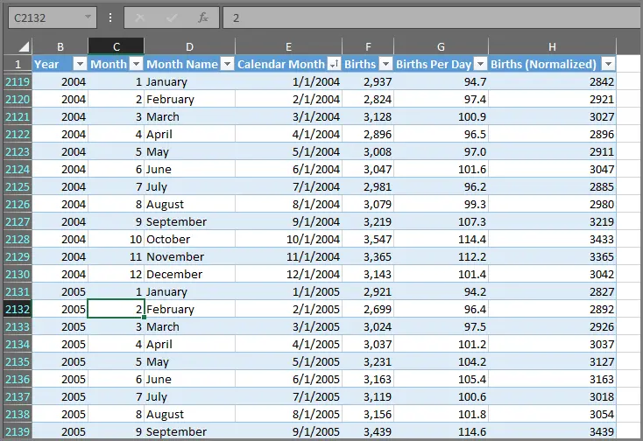

**Datasets** can also be a combination of many different sources, which you can filter and combine to provide a unique collection of data (a dataset) for use in Power BI.

For example, you can create a dataset from three database fields, one website table, an Excel table, and online results of an email marketing campaign. That unique combination is still considered a single **dataset**, even though it was pulled together from many different sources.

Filtering data before bringing it into Power BI lets you focus on the data that matters to you. For example, you can filter your contact database so that only customers who received emails from the marketing campaign are included in the dataset. You can then create visuals based on that subset (the filtered collection) of customers who were included in the campaign. Filtering helps you focus your data—and your efforts.

An important and enabling part of Power BI is the multitude of data **connectors** that are included. Whether the data you want is in Excel or a Microsoft SQL Server database, in Azure or Oracle, or in a service like Facebook, Salesforce, or MailChimp, Power BI has built-in data connectors that let you easily connect to that data, filter it if necessary, and bring it into your dataset.

After you have a dataset, you can begin creating visualizations that show different portions of it in different ways, and gain insights based on what you see. That's where reports come in.

**Reports**

In Power BI, a **report** is a collection of visualizations that appear together on one or more pages. Just like any other report you might create for a sales presentation or write for a school assignment, a report in Power BI is a collection of items that are related to each other. The following image shows a **report** in Power BI Desktop—in this case, it's the second page in a five-page report. You can also create reports in the Power BI service.

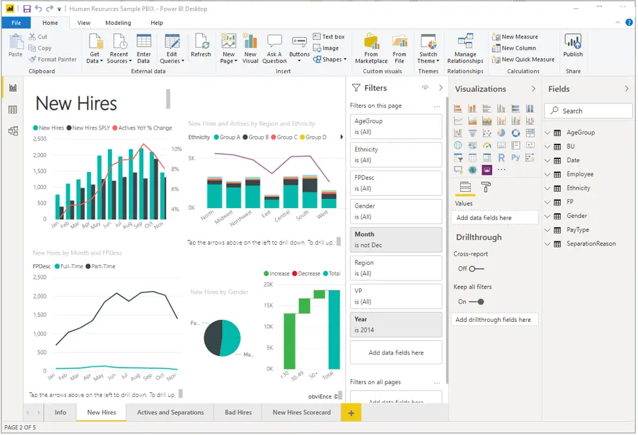

Reports let you create many visualizations, on multiple pages if necessary, and let you arrange those visualizations in whatever way best tells your story.

You might have a report about quarterly sales, product growth in a particular segment, or migration patterns of polar bears. Whatever your subject, reports let you gather and organize your visualizations onto one page (or more).

**Dashboards**

When you're ready to share a report, or a collection of visualizations, you create a **dashboard**. Much like the dashboard in a car, a Power BI **dashboard** is a collection of visuals that you can share with others. Often, it's a selected group of visuals that provide quick insight into the data or story you're trying to present.

A dashboard must fit on a single page, often called a canvas (the canvas is the blank backdrop in Power BI Desktop or the service, where you put visualizations). Think of it like the canvas that an artist or painter uses—a workspace where you create, combine, and rework interesting and compelling visuals. You can share dashboards with other users or groups, who can then interact with your dashboards when they're in the Power BI service or on their mobile device.

**Tiles**

In Power BI, a **tile** is a single visualization on a dashboard. It's the rectangular box that holds an individual visual. In the following image, you see one tile, which is also surrounded by other tiles.

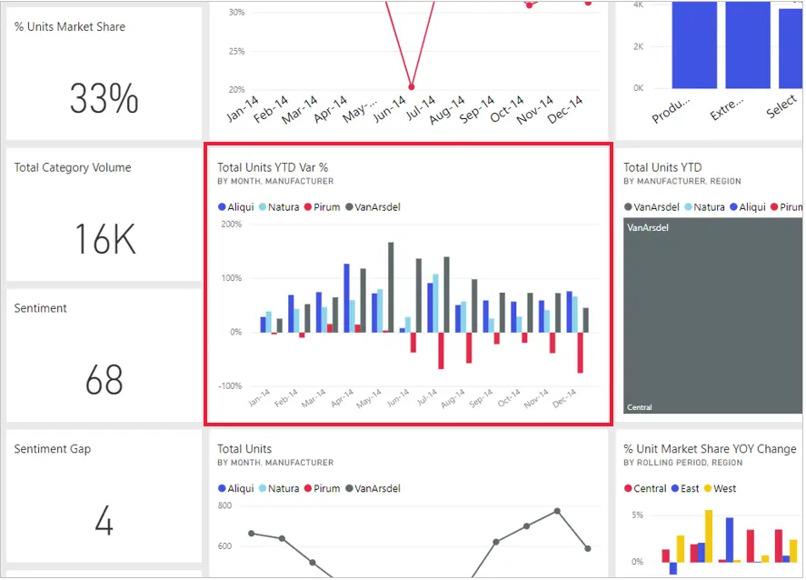

When you're *creating* a dashboard in Power BI, you can move or arrange tiles however you want. You can make them bigger, change their height or width, and snuggle them up to other tiles.

When you're *viewing*, or *consuming*, a dashboard or report—which means you're not the creator or owner, but the report or dashboard has been shared with you—you can interact with it, but you can't change the size of the tiles or their arrangement.

**All together now**

Those are the basics of Power BI and its building blocks. Let's take a moment to review.

Power BI is a collection of services, apps, and connectors that lets you connect to your data, wherever it happens to reside, filter it if necessary, and then bring it into Power BI to create compelling visualizations that you can share with others.

Now that you've learned about the handful of basic building blocks of Power BI, it should be clear that you can create datasets that make sense *to you* and create visually compelling reports that tell your story. Stories told with Power BI don't have to be complex, or complicated, to be compelling.

For some people, using a single Excel table in a dataset and then sharing a dashboard with their team will be an incredibly valuable way to use Power BI.

For others, the value of Power BI will be in using real-time Azure SQL Data Warehouse tables that combine with other databases and real-time sources to build a moment-by-moment dataset.

For both groups, the process is the same: create datasets, build compelling visuals, and share them with others. And the result is also the same for both groups: harness your ever-expanding world of data, and turn it into actionable insights.

Whether your data insights require straightforward or complex datasets, Power BI helps you get started quickly and can expand with your needs to be as complex as your world of data requires. And because Power BI is a Microsoft product, you can count on it being robust, extensible, Microsoft Office–friendly, and enterprise-ready.

Now let's see how this works. We'll start by taking a quick look at the Power BI service.

**Next unit: Tour and use the Power BI service**

**Tour and use the Power BI service**

Completed100 XP

* 12 minutes

As we learned in the previous unit, the common flow of work in Microsoft Power BI is to create a report in Power BI Desktop, publish it to the Power BI service, and then share it with others, so that they can view it in the service or on a mobile app.

But because some people begin in the Power BI service, let's take a quick look at that first, and learn about an easy and popular way to quickly create visuals in Power BI: *apps*.

An **app** is a collection of preset, ready-made visuals and reports that are shared with an entire organization. Using an app is like microwaving a TV dinner or ordering a fast-food value meal: you just have to press a few buttons or make a few comments, and you're quickly served a collection of entrees designed to go together, all presented in a tidy, ready-to-consume package.

So, let's take a quick look at apps, the service, and how it works. We'll go into more detail about apps (and the service) in upcoming modules, but you can think of this as a taste to whet your appetite. You can sign into the service at [https://powerbi.microsoft.com](https://powerbi.microsoft.com/).

**Create out-of-box dashboards with cloud services**

With Power BI, connecting to data is easy. From the Power BI service, you can just select the **Get Data** button in the lower-left corner of the home page.

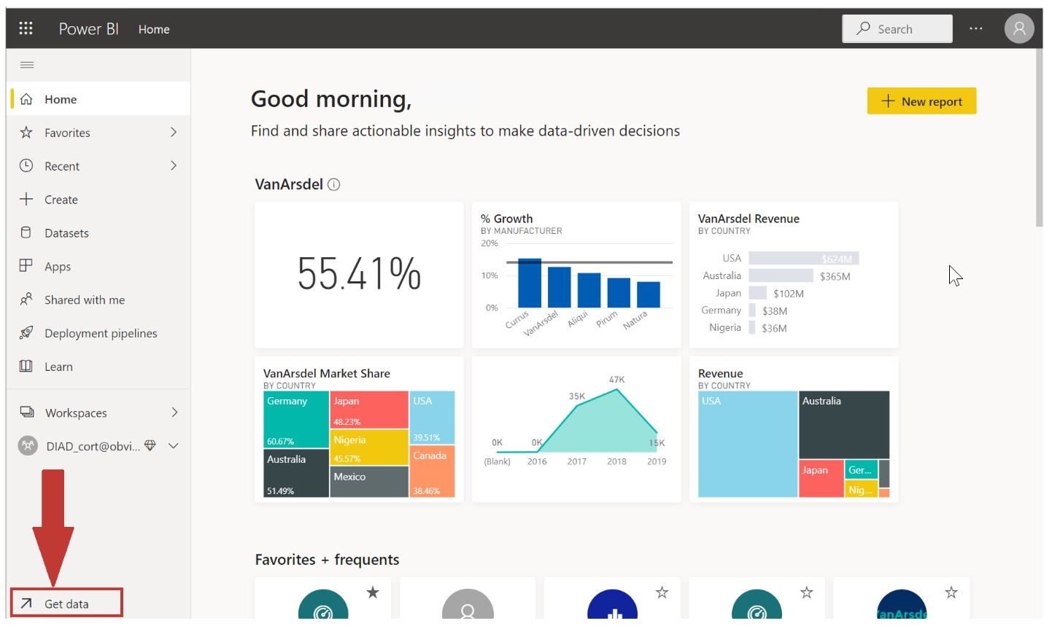

The *canvas* (the area in the center of the Power BI service) shows you the available sources of data in the Power BI service. In addition to common data sources like Microsoft Excel files, databases, or Microsoft Azure data, Power BI can just as easily connect to a whole assortment of **software services** (also called SaaS providers or cloud services): Salesforce, Facebook, Google Analytics, and more.

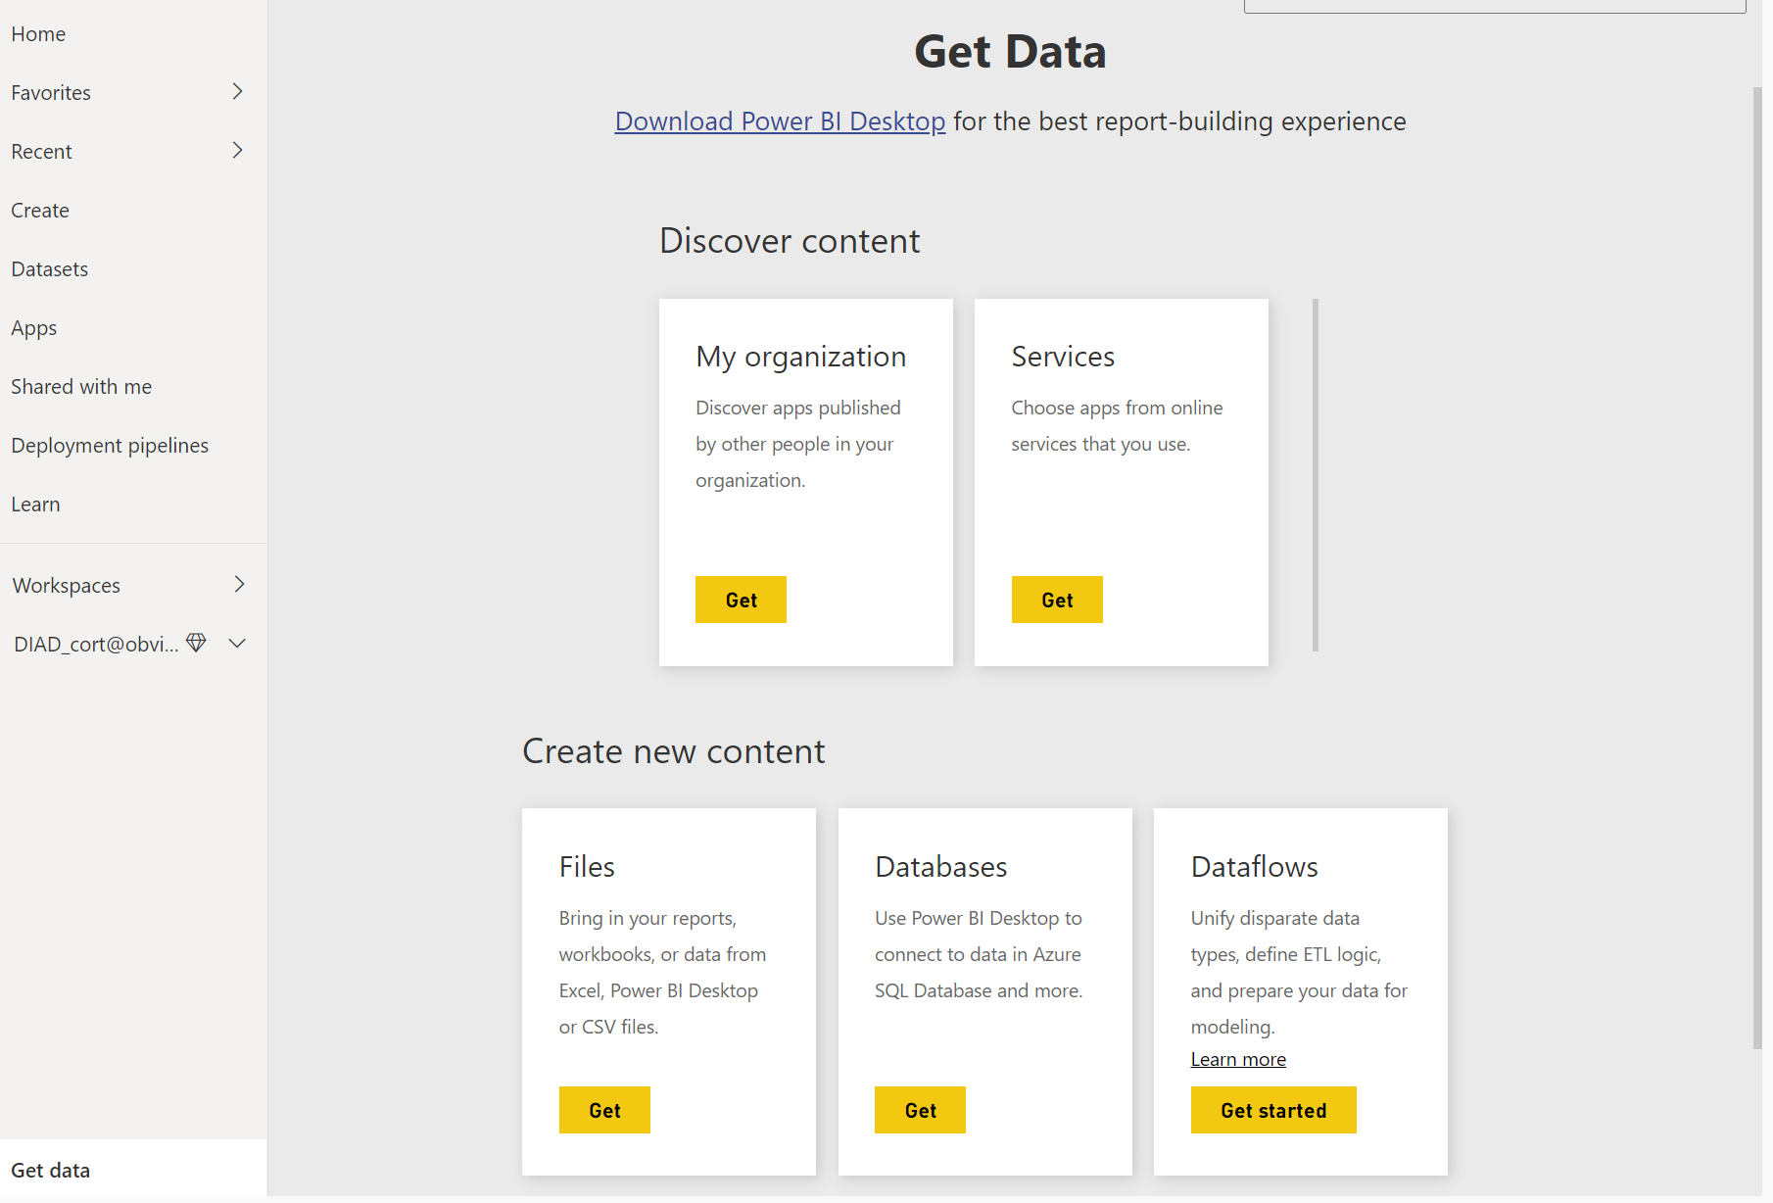

For these software services, the **Power BI service** provides a collection of ready-made visuals that are pre-arranged on dashboards and reports for your organization. This collection of visuals is called an **app**. Apps get you up and running quickly, with data and dashboards that your organization has created for you. For example, when you use the GitHub app, Power BI connects to your GitHub account (after you provide your credentials) and then populates a predefined collection of visuals and dashboards in Power BI.

There are apps for all sorts of online services. The following image shows a page of apps that are available for different online services, in alphabetical order. This page is shown when you select the **Get** button in the **Services** box (shown in the previous image). As you can see from the following image, there are many apps to choose from.

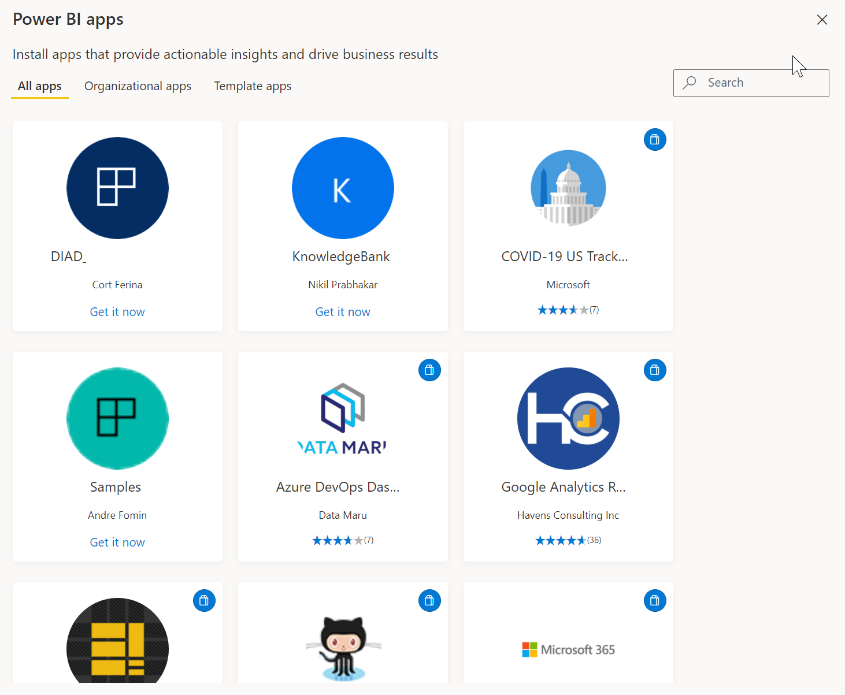

For our purposes, we'll choose **GitHub**. Note that the GitHub app requires Power BI Pro. GitHub is an application for online source control. When you select the **Get it now** button in the box for the GitHub app, the **Connect to GitHub** dialog box appears. Note that GitHub does not support Internet Explorer, so make sure you are working in another browser.

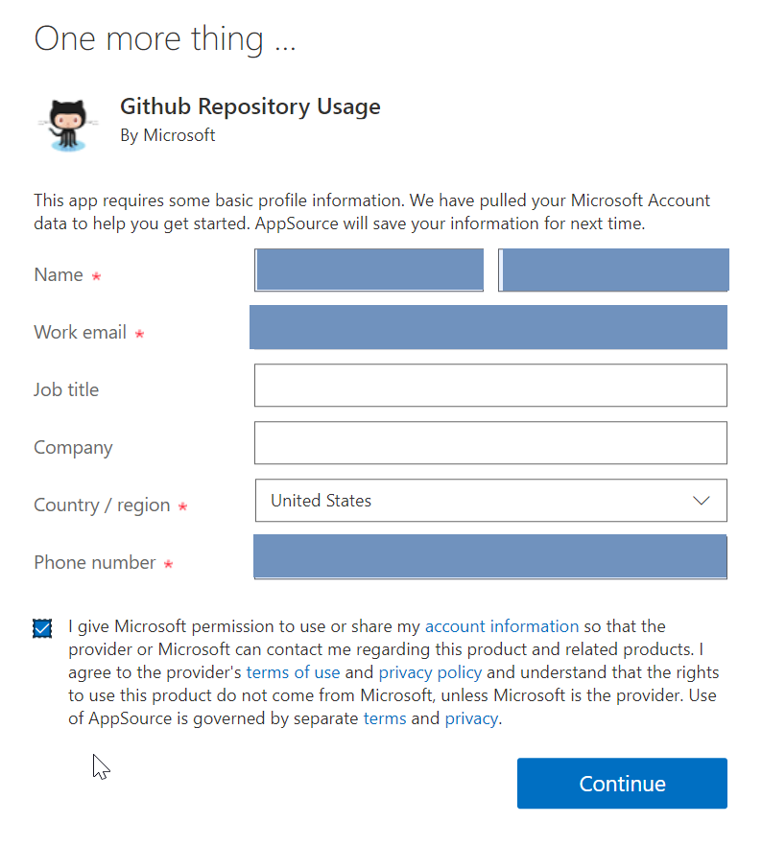

After you enter the information and credentials for the GitHub app, installation of the app begins.

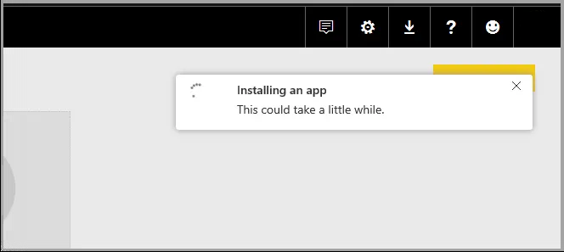

After the data is loaded, the predefined GitHub app dashboard appears.

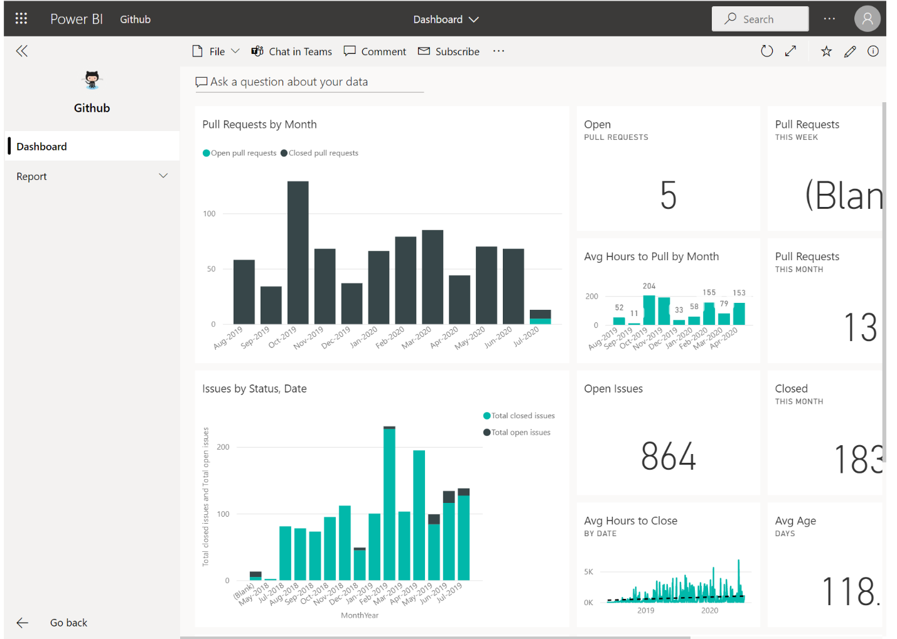

In addition to the app **dashboard**, the **report** that was generated (as part of the GitHub app) and used to create the dashboard is available, as is the **dataset** (the collection of data pulled from GitHub) that was created during data import and used to create the GitHub report.

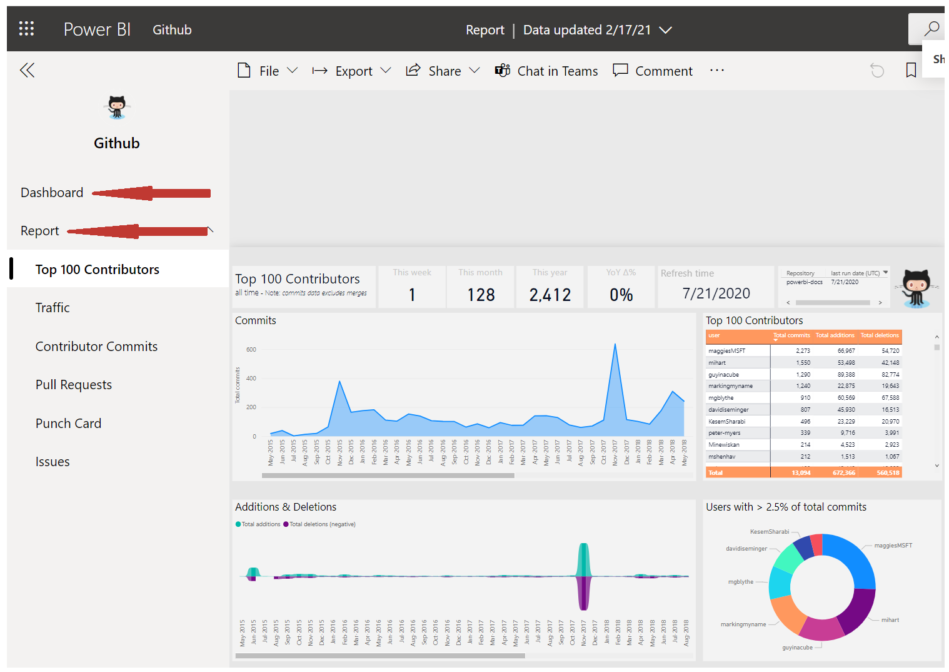

You can select any of the visuals and interact with them. If you click on a section in one visual, all the other visuals on the page will filter accordingly. For example, when you click on **MIHART** in the donut chart on the **Pull Requests** report, the other visuals on the page adjust to reflect that selection.

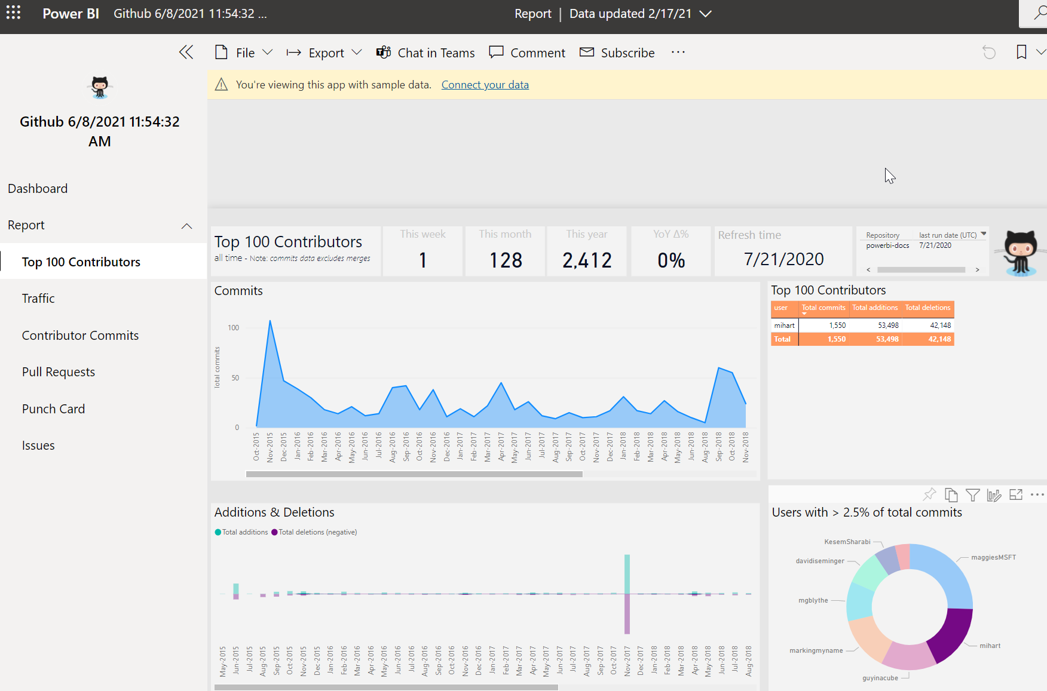

**Update data in the Power BI service**

You can also choose to **update** the dataset for an app, or other data that you use in Power BI. To set update settings, select the schedule update icon for the dataset to update, and then use the menu that appears. You can also select the update icon (the circle with an arrow) next to the schedule update icon to update the dataset immediately.

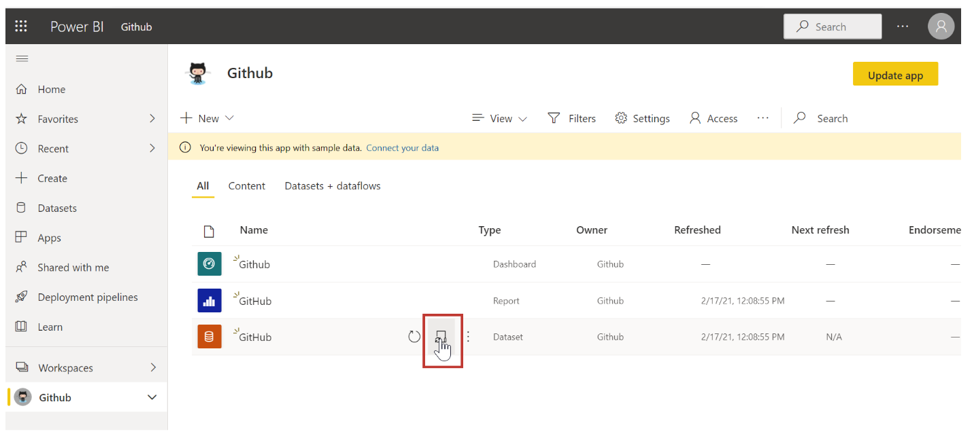

The **Datasets** tab is selected on the **Settings** page that appears. In the right pane, select the arrow next to **Scheduled refresh** to expand that section. The **Settings** dialog box appears on the canvas, letting you set the update settings that meet your needs.

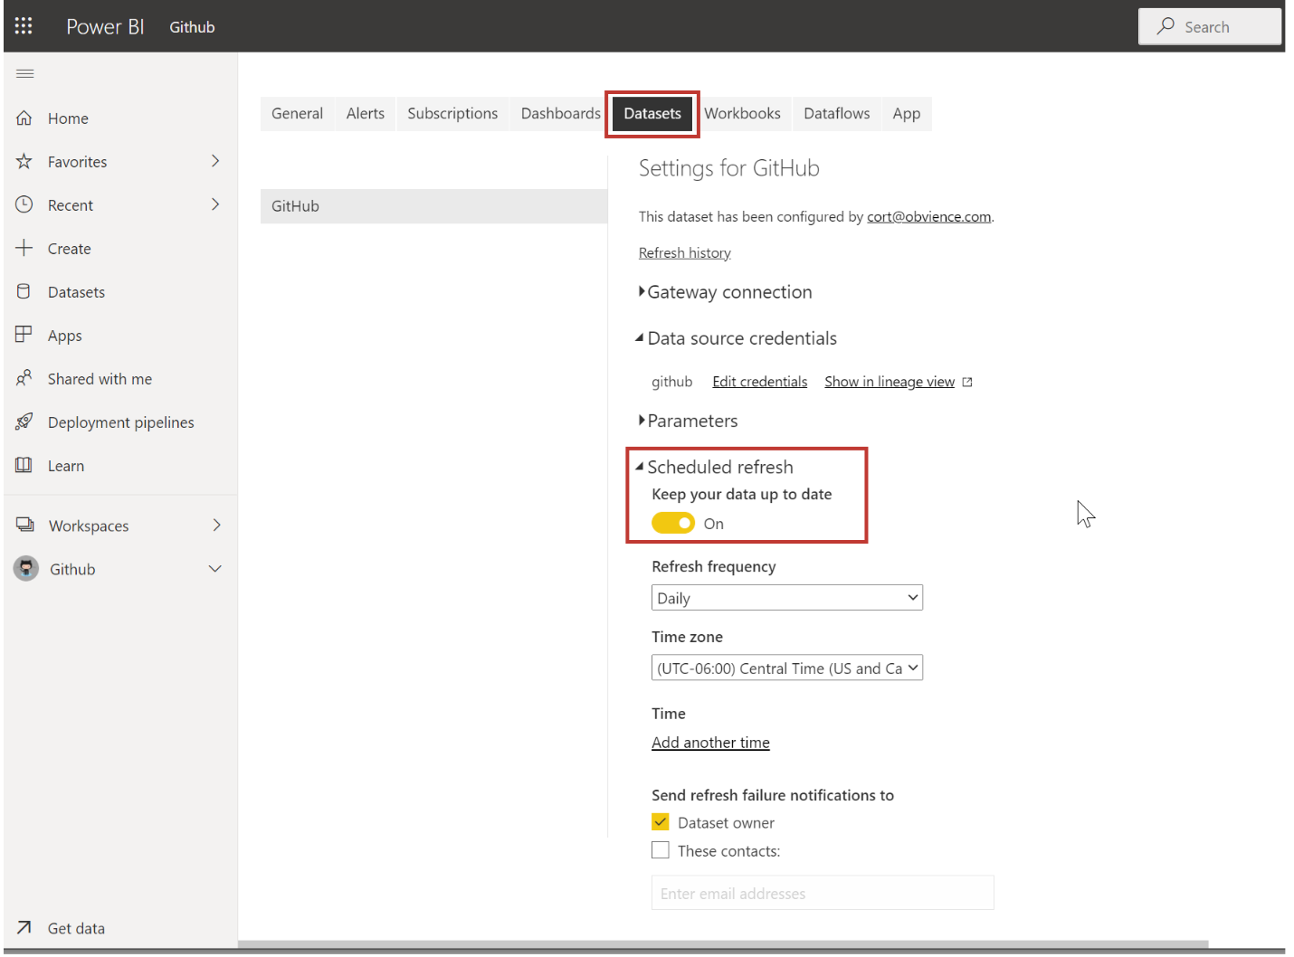

That's enough for our quick look at the Power BI service. There are many more things you can do with the service, and we'll cover these later in this module and in upcoming modules. Also, remember that there are many types of data you can connect to, and all sorts of apps, with more of both coming all the time.

**Next unit: Summary**

**Summary**

Completed100 XP

* 5 minutes

Let's do a quick review of what we covered in this module.

**Microsoft Power BI** is a collection of software services, apps, and connectors that work together to turn your data into interactive insights. You can use data from single basic sources, like a Microsoft Excel workbook, or pull in data from multiple databases and cloud sources to create complex datasets and reports. Power BI can be as straightforward as you want or as enterprise-ready as your complex global business requires.

Power BI consists of three main elements—**Power BI Desktop**, the **Power BI service**, and **Power BI Mobile**—which work together to let you create, interact with, share, and consume your data the way you want.



We also discussed the basic building blocks in Power BI:

* **Visualizations** – A visual representation of data, sometimes just called visuals
* **Datasets** – A collection of data that Power BI uses to create visualizations
* **Reports** – A collection of visuals from a dataset, spanning one or more pages
* **Dashboards** – A single-page collection of visuals built from a report
* **Tiles** – Snapshots of your data on a dashboard

In the **Power BI service**, we installed an **app** in just a few clicks. That **app**, a ready-made collection of visuals and reports, let us easily connect to a **software service** to populate the app and bring that data to life.

Finally, we set up a **refresh schedule** for our data, so that we know the data will be fresh when we go back to the Power BI service.

**Next steps**

**Congratulations!** You've finished the first module of the **learning path** for Power BI. You now have a firm foundation of knowledge for when you move on to the next module, which walks through the steps to create your first report.

We mentioned this before, but it's worth restating: this learning path builds your knowledge by following the common flow of work in Power BI:

* Bring data into **Power BI Desktop**, and create a report.
* **Publish** to the Power BI service, where you create new visualizations or build dashboards.
* **Share** your dashboards with others, especially people who are on the go.
* View and interact with shared dashboards and reports in **Power BI Mobile** apps.



You might not do all that work yourself—some people will only view dashboards that were created by someone else, and they'll just use the service. That's fine, and we'll soon have a module dedicated to showing how you can easily navigate and use the **Power BI service** to view and interact with reports and apps.

But the next module follows the flow of work in Power BI, showing you how to create a report and publish it to the Power BI service. You'll learn how those reports and dashboards are created and how they are connected to the data. You might even decide to create a report or dashboard of your own.

See you in the next module!

**Check your knowledge**

Completed200 XP

* 3 minutes

**Knowledge check Get started with Power BI**

Top of Form

**1.**

What is the common flow of activity in Power BI?



Create a report in Power BI mobile, share it to the Power BI Desktop, view and interact in the Power BI service.



Create a report in the Power BI service, share it to Power BI mobile, interact with it in Power BI Desktop.



Bring data into Power BI Desktop and create a report, share it to the Power BI service, view and interact with reports and dashboards in the service and Power BI mobile.

**The Power BI service lets you view and interact with reports and dashboards, but doesn't let you shape data.**



Bring data into Power BI mobile, create a report, then share it to Power BI Desktop.

**2.**

Which of the following are building blocks of Power BI?



Tiles, dashboards, databases, mobile devices.



Visualizations, datasets, reports, dashboards, tiles.

**Building blocks for Power BI are visualizations, datasets, reports, dashboards, tiles.**



Visual Studio, C#, and JSON files.

**3.**

A collection of ready-made visuals, pre-arranged in dashboards and reports is called what in Power BI?



The canvas.



Scheduled refresh.



An app.

**An app is a collection of ready-made visuals, pre-arranged in dashboards and reports. You can get apps that connect to many online services from the AppSource.**

Bottom of Form